**Project Increment - 1**

**CSEE 5590-0002 : Web/Mobile Programming**

# **KC Donation Web Application**

# **Team 3**

## Roshna Toke, ClassID: 23

## Manaswini Vedula, ClassID: 24

## Yamini Saraswathi Bommineni, ClassID: 03

### **Motivation:**

Food is the primary essential need. Many people suffer from hunger because of a shortage of food and at the same time lots of excessive food has been wasted in the restaurants. So, the main motivation of this application is to create a bridge between the Donor and users and making excessive food to reach for the people who are in need.

### **Significance:**

The significance of this application is that it can fill the gap between the people having excessive food and people who are looking for food out of hunger. The people having excessive food like restaurants businesspeople can upload their excessive food into the Donor page after uploading the Users can find the food available for donating and can access that through the user's page as per their need.

### **Objectives:**

The main objective of this project is to design a system where donors (those who have excess food items) can donate their food items only by posting its description on the system and then the requester will request that as per their need and collect from a given address.

### **System Features:**

**Main Page**: Welcome Page of this application where User and Donor both can **Login** and **Register**.

**Donor**: On the donor page, the donor can add food items he wants to donate, delete added food items and he can see his history of food donation from starting

**Requester**: On the requester page, when the donor adds his food items then that food item will be visible to all requesters. Requesters can request that food item then it won’t be visible on requesters as well as donors page. Also, the requester can see his history from starting.

### **Demo Screens:**

1. **Main Page**

**This is screenshot Main Page of the ‘KC Donation’ web application. Here we have given ‘Sign-in’ and ‘Login’ functionalities.**

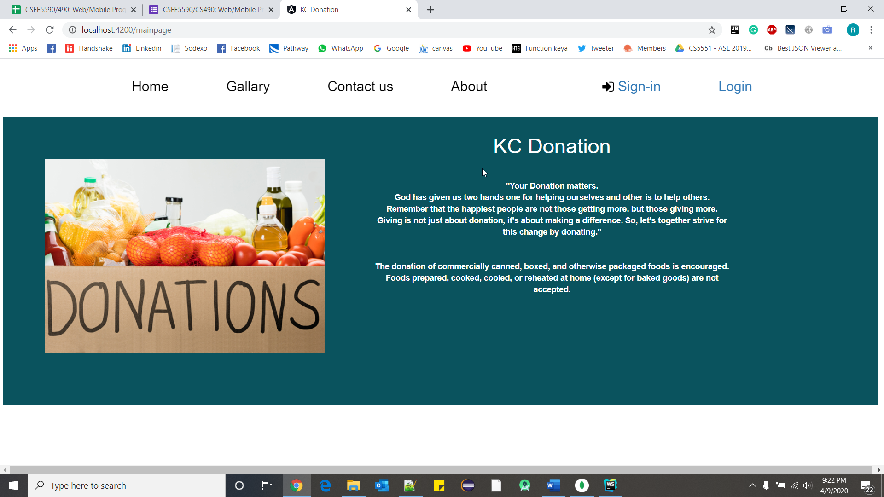

1. **Registration Page**

**This is the screenshot of the registration page. First time user should sign up before he can login to the application and all the fields in this page are mandatory. We have also included some validations like both password and confirm password are same and check all the fields are filled up after the user clicks sign up.**

**User type can be either ‘Donor’ or ‘Requestor’.**

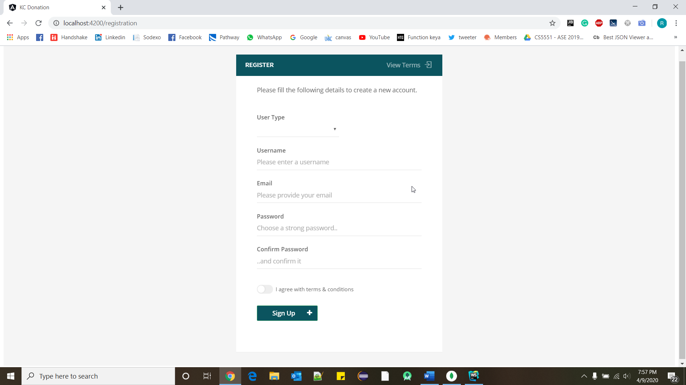

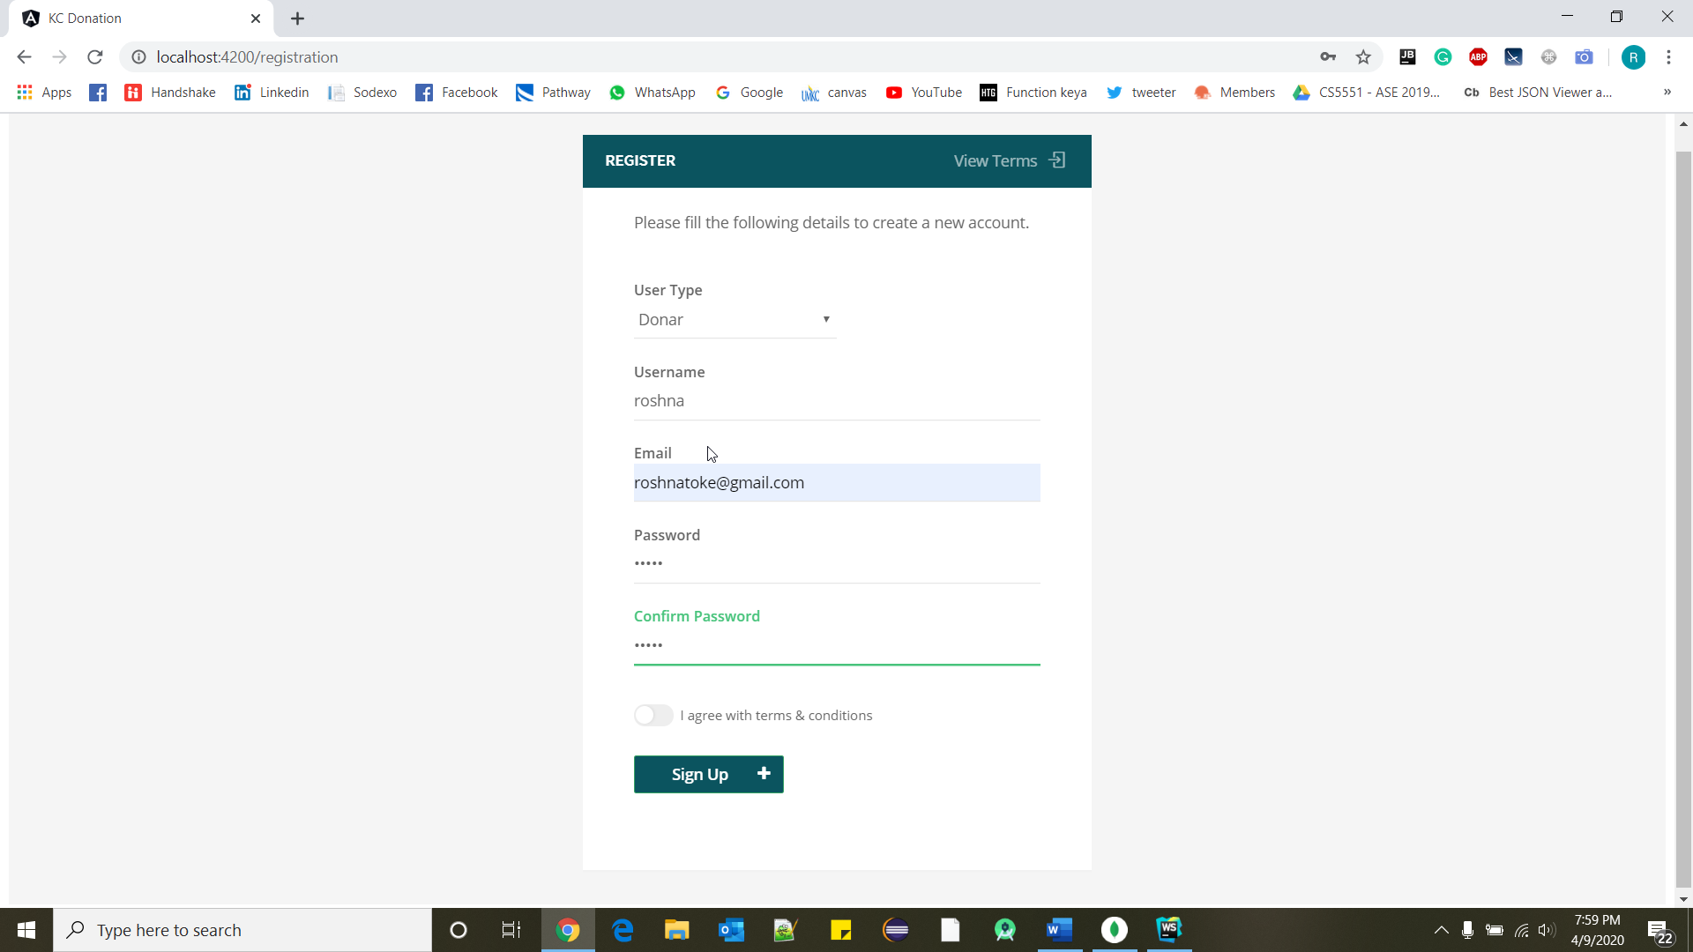

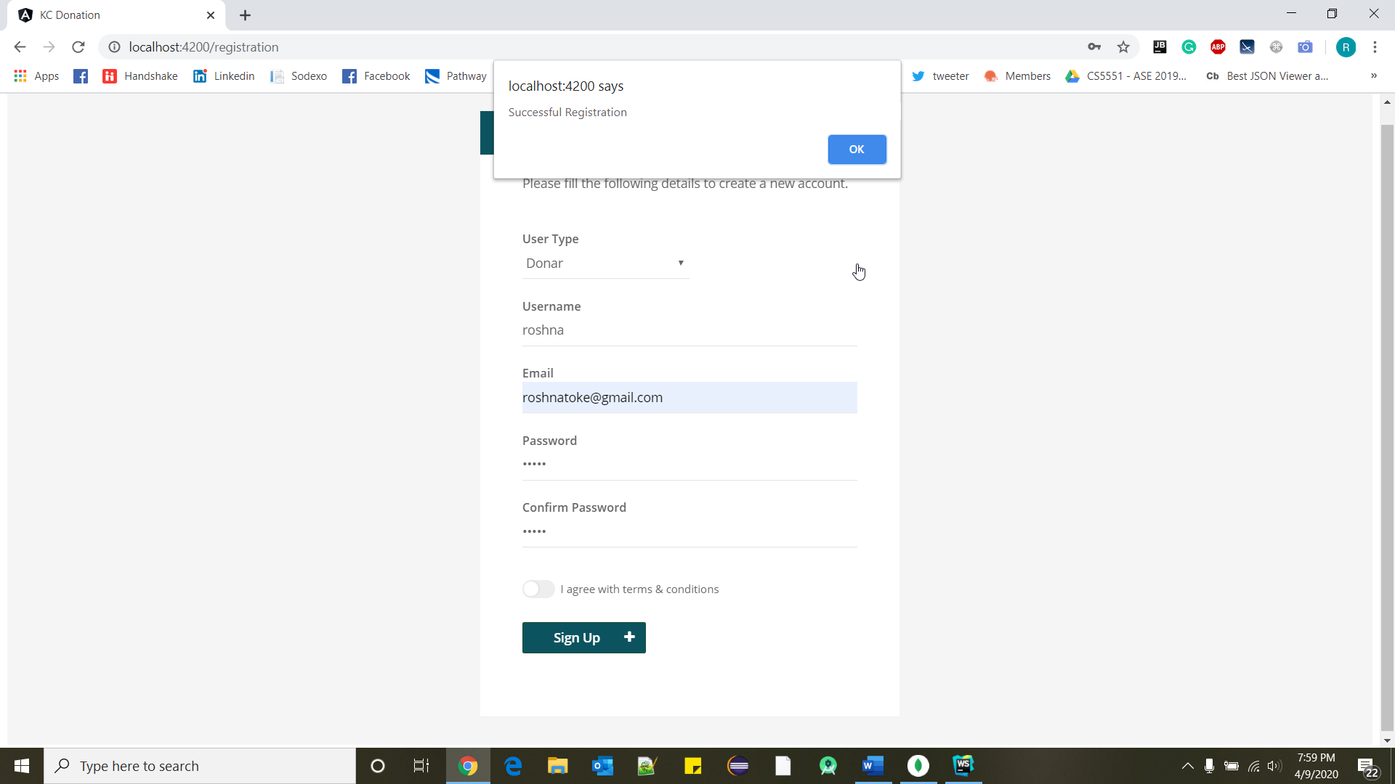

1. **Login Page**

**This is the screenshot of the login page. Here as the user enters his/her details it will check automatically if the credentials match with any of the users who have registered and if it matched it navigates to home page. If the credentials do not match then it prompts that username or password is wrong.**

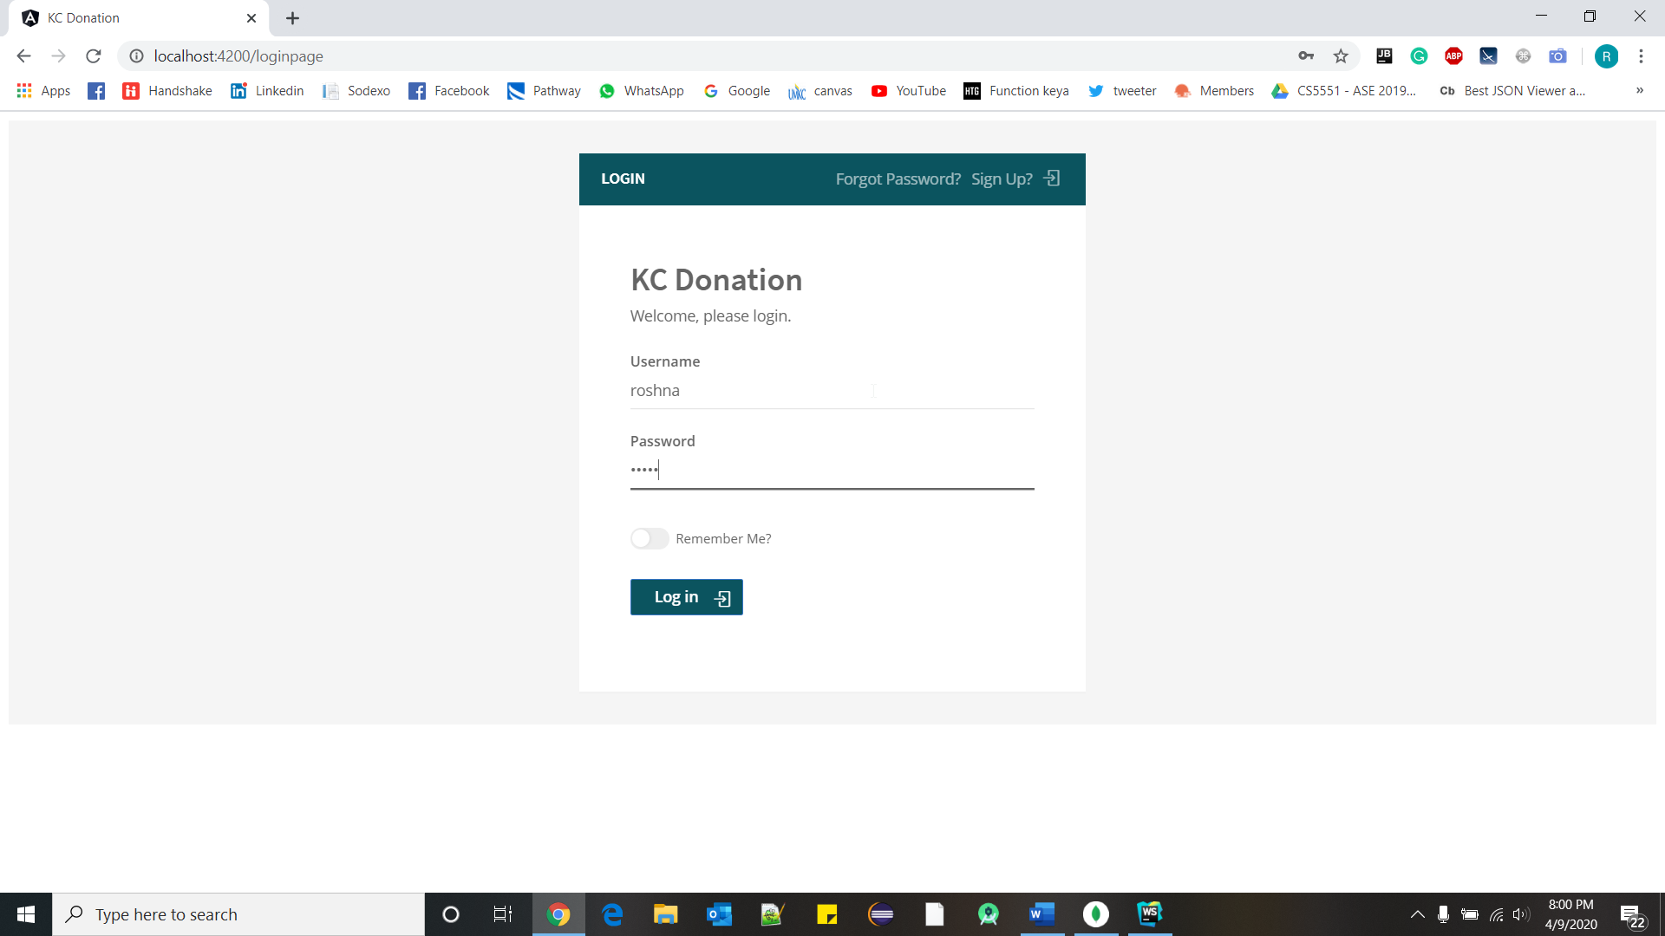

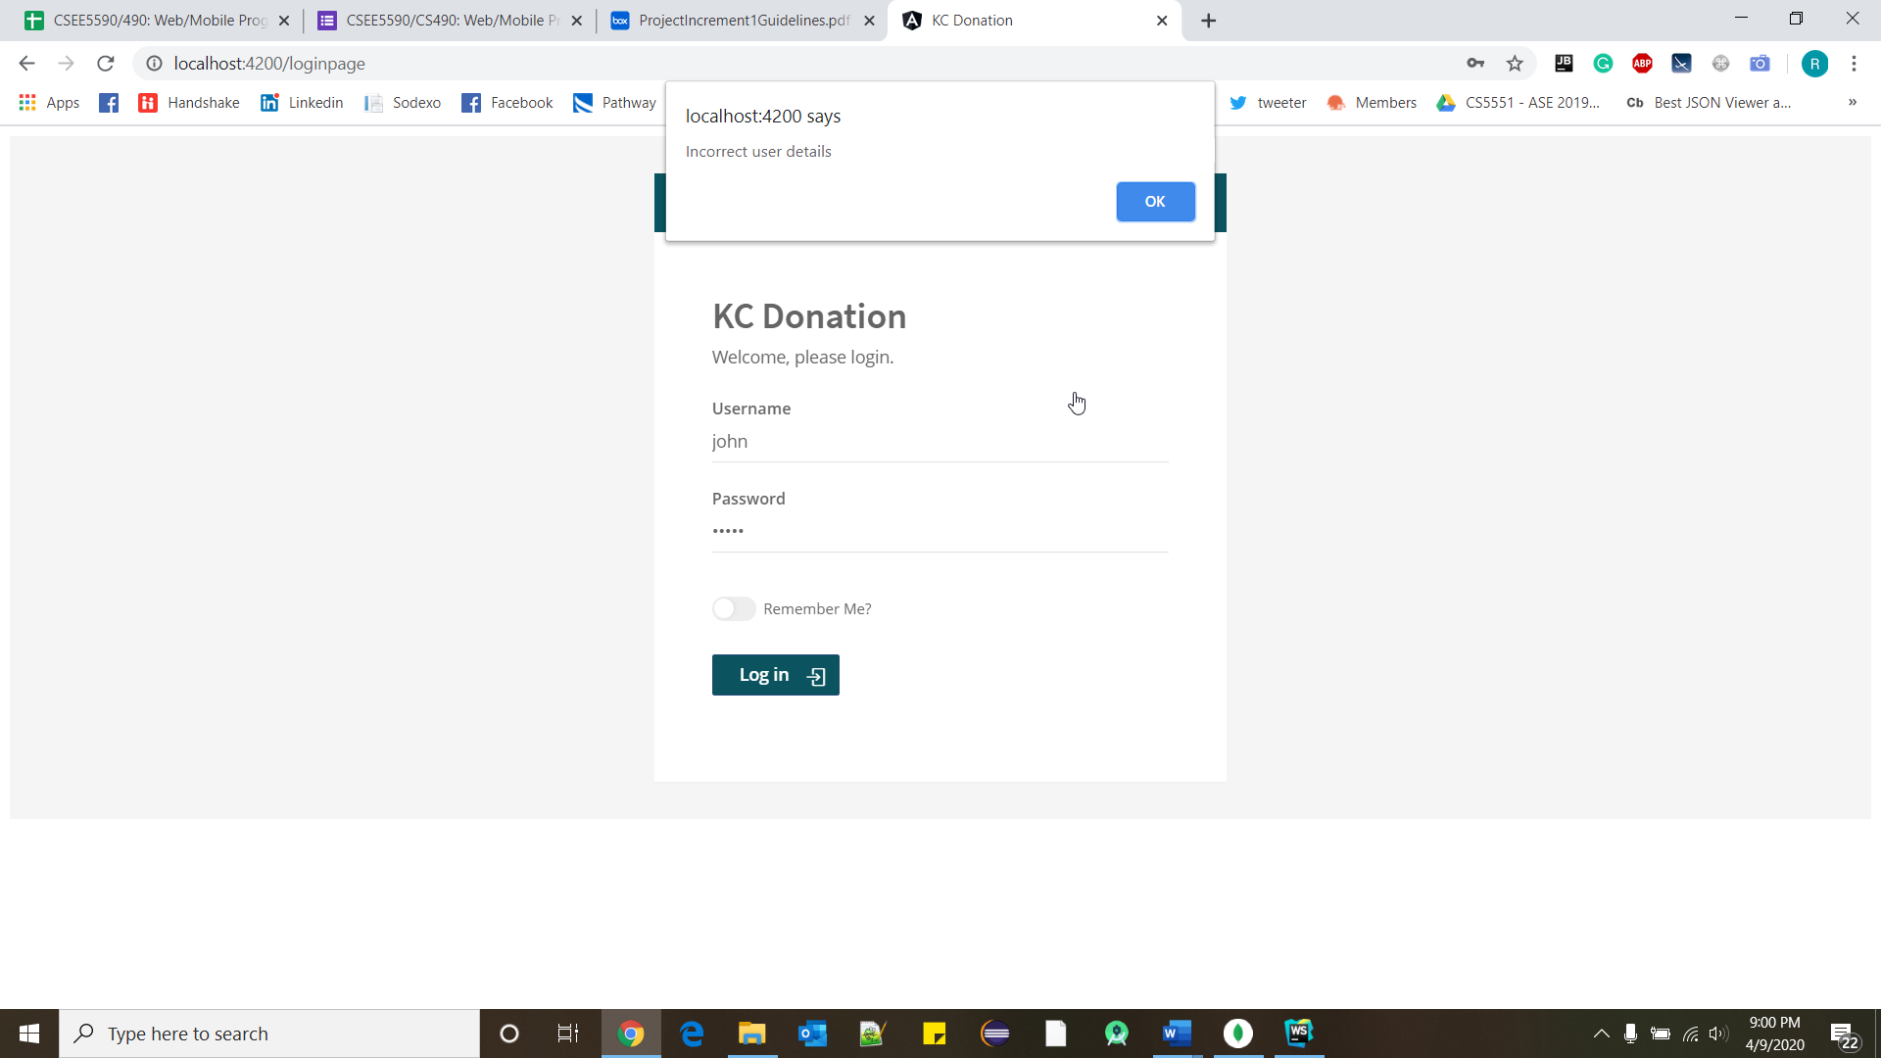

1. **Forgot Password**

**If the user forgets his/her password, then by clicking forgot password button he will be navigated to this page. Here as the user enters his email and clicks send email then an email with a new password will be sent to users account.**

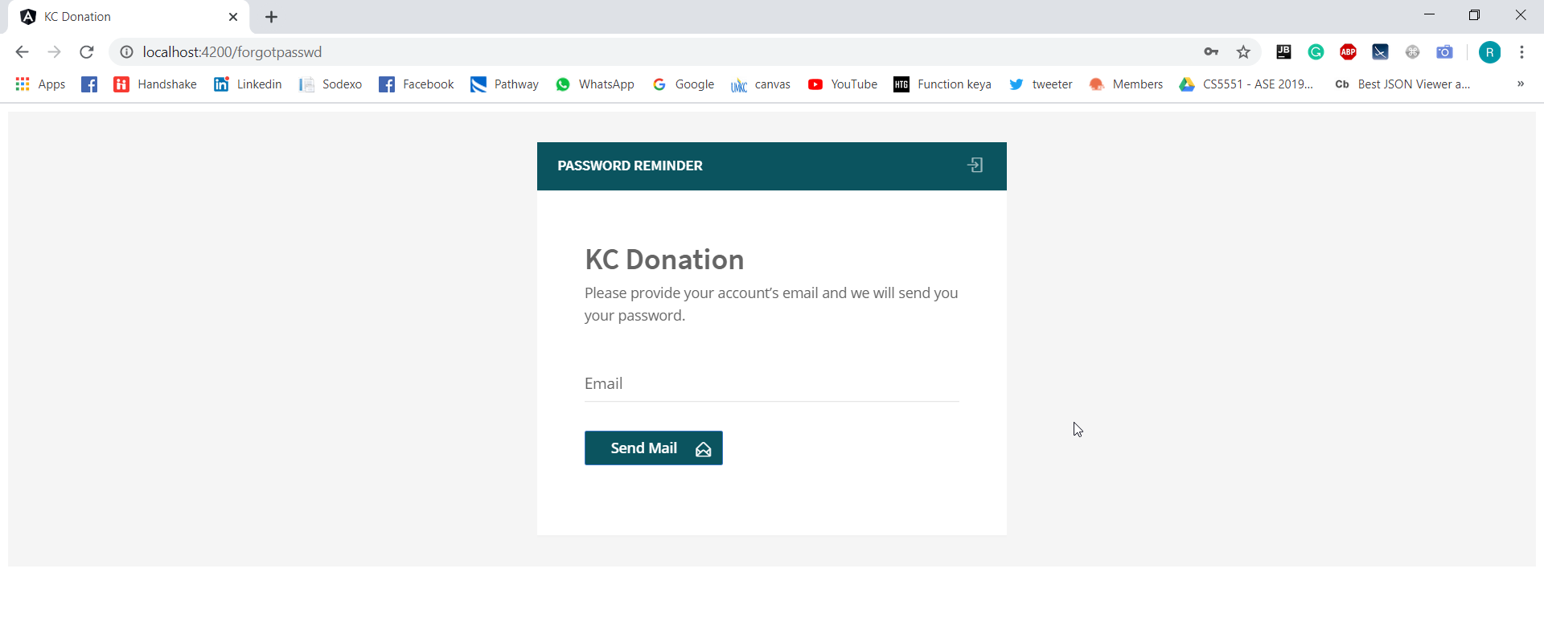

1. **Donor Page**

**In Donor page we have given two buttons, one is for donation and another one is for seeing history of users donation.**

**When user click on logout button it will re-direct to main page of the application.**

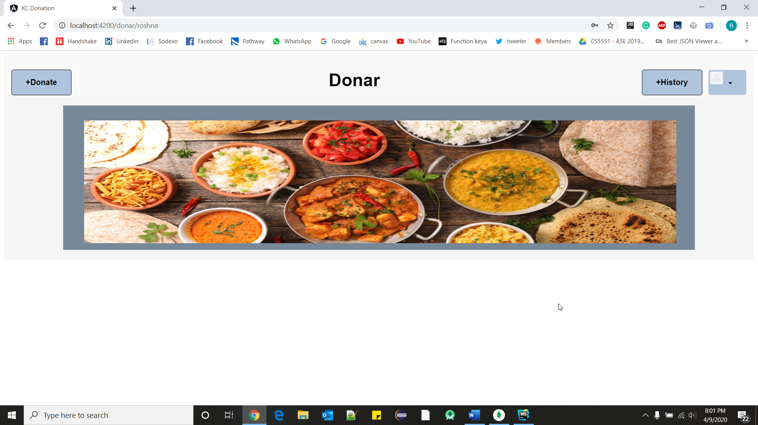

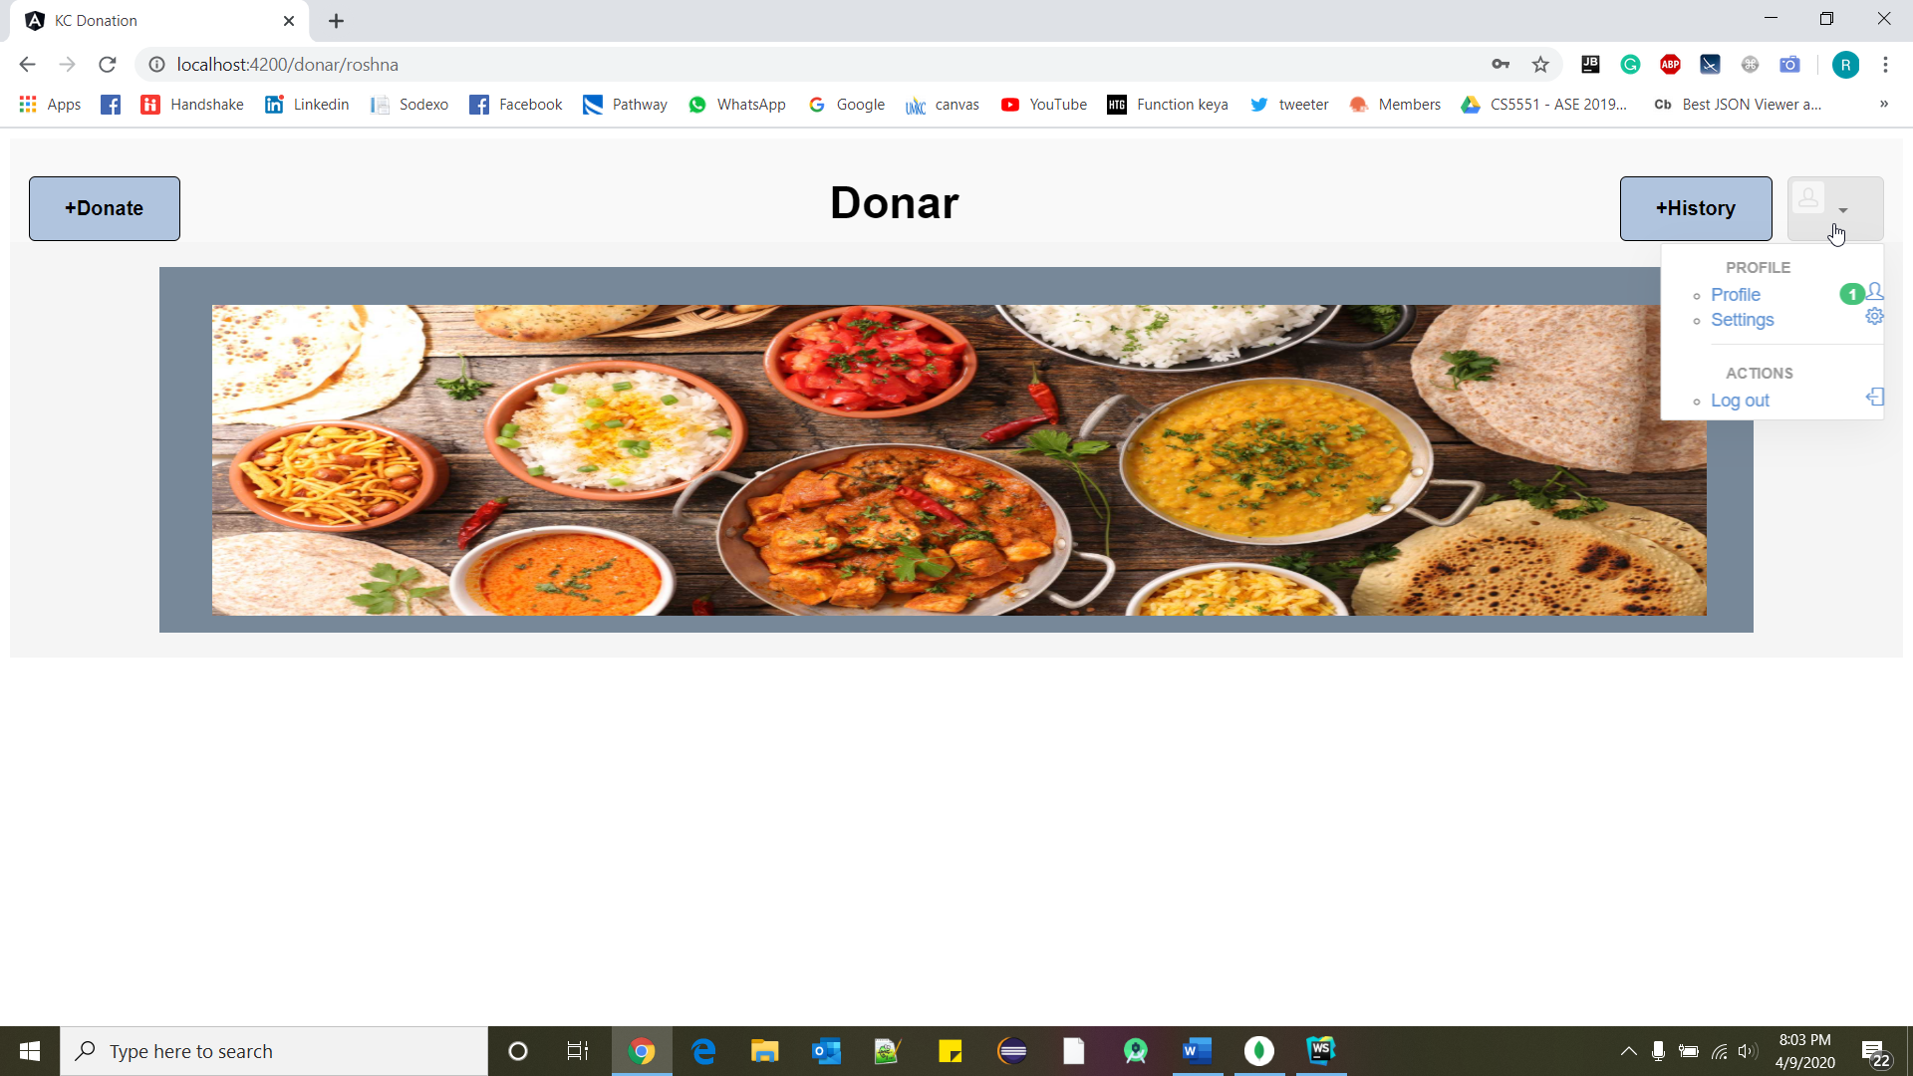

1. **Requester Page**

**This is requestor page. Here we have given history button for requestor to see his history.**

**Whatever donor will add in his window, requester can see those item in his bucket.**

**When user click on logout button he/she will redirect to main page of the application.**

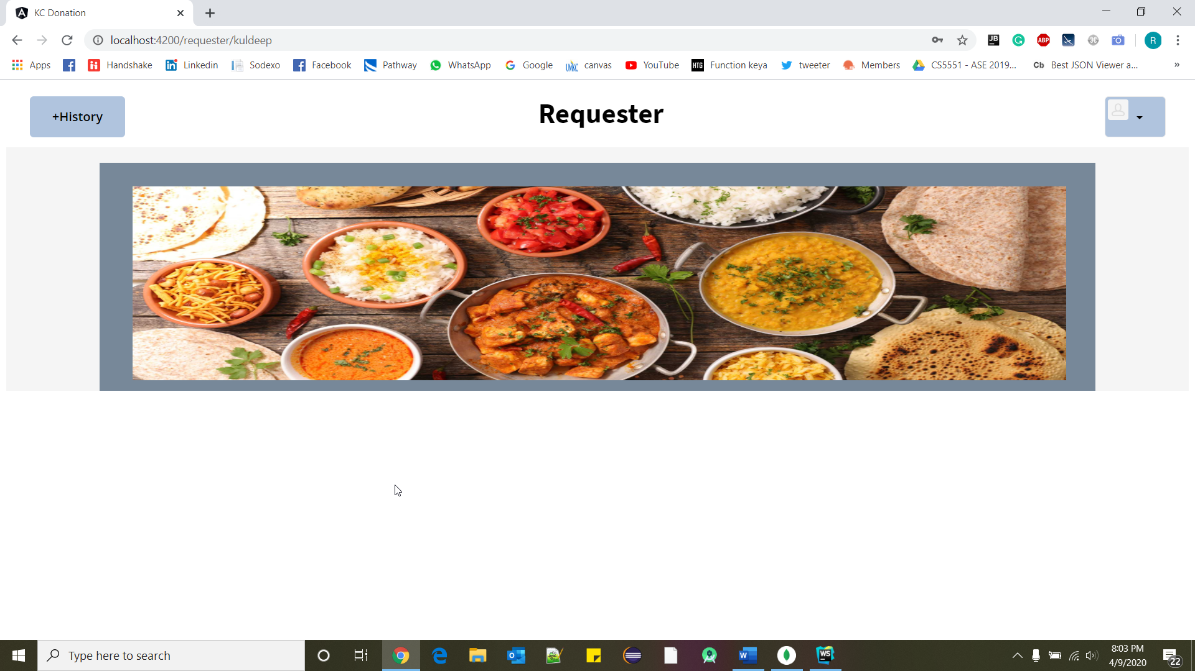

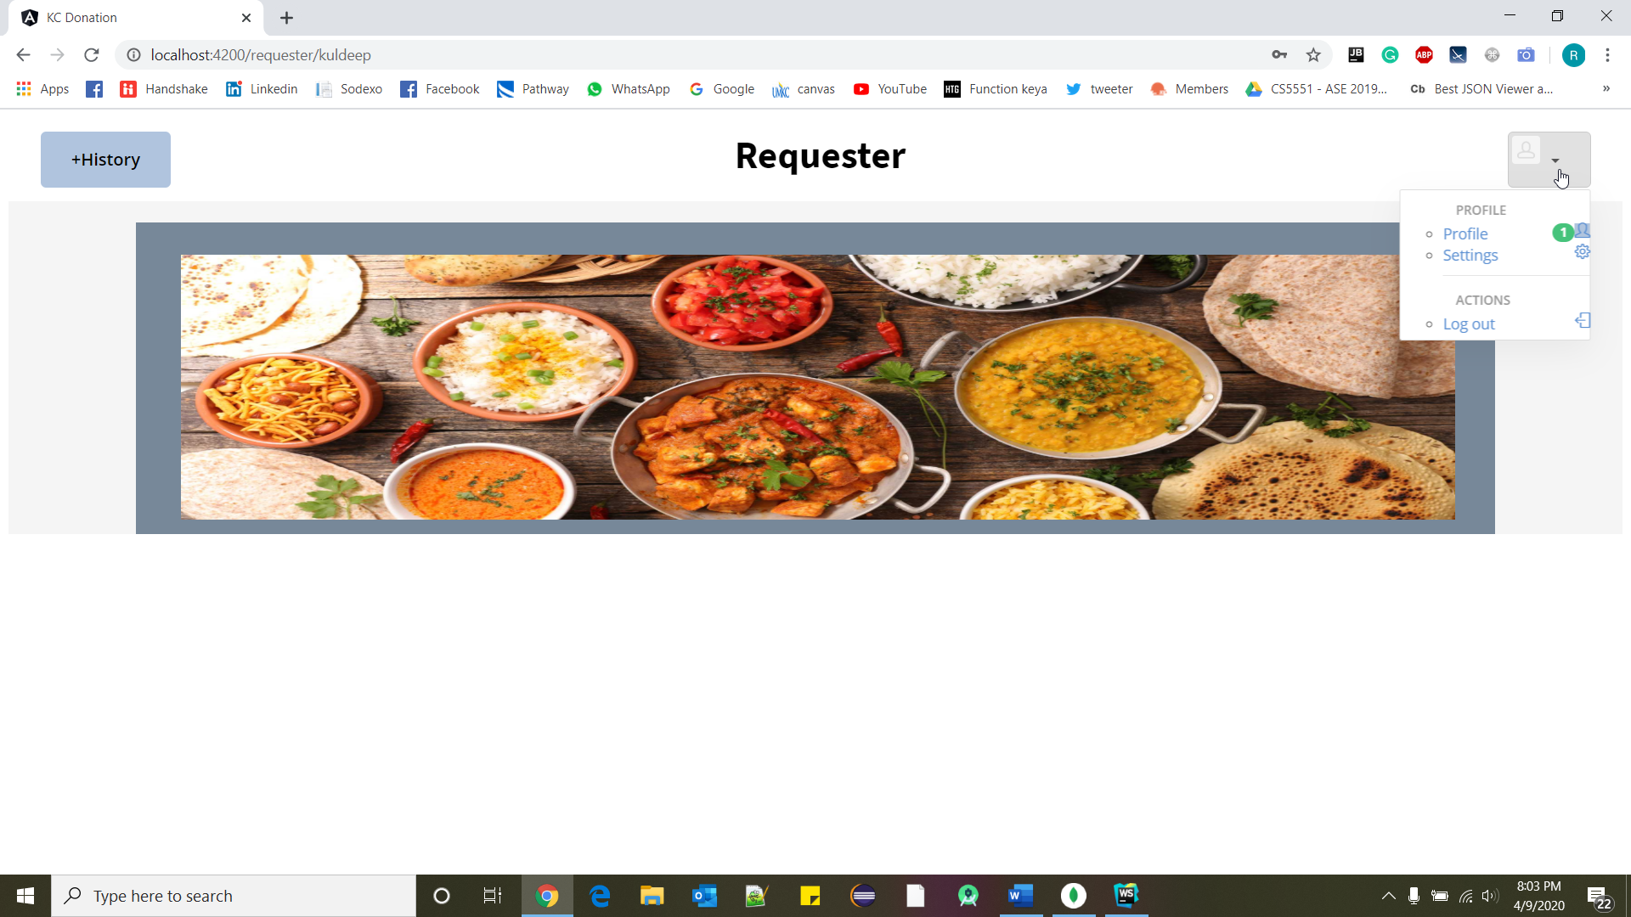

### **Improvement from the proposal state:**

1. Design Main page of the application.
2. Registration functionality.
3. Login functionality.
4. Forget Password window.
5. Design Donor and Requester Page.
6. Routing for all pages including Logout button.

### **GitHub Link:**

### <https://github.com/roshna1924/KC-Donation>

### **Work sharing between teammates:**

All are equally working in developing functionalities and designing webpages.

### **Technologies used:**

MEAN stack

Angular JS

HTML, CSS, Bootstrap

Node JS

Mongo DB

### **References:**

Hackathon Use Case - <https://umkc.app.box.com/s/gg46llw7gye4is7ujhohw00a2sody7mb>

<https://www.w3schools.com/>

[www.google.com](http://www.google.com)

<https://mongoosejs.com/docs/api.html>